Chapter 6: JavaScript
Introduction
- JavaScript: It is a programming language used for web applications.
- Its code is written within an HTML program, hence saved with extension .html
- <script> tag: is used for JavaScript programs.
- document.write : This is a function used to display results of JavaScript in an HTML program. E.g. document.write(“This is my first JavaScript program”);
- To display output (result) in text form: type = “text/javascript”

Program: firstJSprogram.html
<DOCTYPE html>
<html>
<body>
<script>
type="text/javascript">
document.write(“This is my first JavaScript
program");
</script>
</body>
</html>

Arithmetic Operations
Arithmetic Operators
+ (plus): for addition
- (minus): for subtraction
* (asterisk): for multiplication
/ (slash): for division
Declaration of variables: we use the word var e.g. var A = 10;
reserves an area for variable A and puts a value 10 in it. Note: There is a semi-colon after JavaScript statement.

Example – Addition
Write a program which adds 2 numbers A and B having values 10 and 15 respectively and get the sum in C.
<!DOCTYPE html>
<html>
<body>
<script>
var A=10;
var B=15;
var C=A+B;
document.write("The Total = "+C);
</script>
</body>
</html>

Creating Forms
- A "form" on a website is a section of a webpage that allows users to input information, typically by filling in fields like their name, email address, or other details
- Form is then submitted to the website owner to collect data or process a request
- Examples: Forms for jobs, admissions, contacting customer service etc.
- It is essentially an interactive tool for gathering user information directly on the website

Creating Forms – Example Program
<!DOCTYPE html>
<html>
<body>
<h2>Application Form for job of Web Engineer</h2>
<form>
<label for="fname">First name:</label><br>
<input type="text" id="fname" name="fname" value=""><br>
<label for="lname">Last name:</label><br>
<input type="text" id="lname" name="lname" value="">
</form>
</body>
</html>

Components of the Form
- To create a form, we use <form> element and where form is complete, it is closed </form>
- <label> element is the title (heading) of a field e.g. First name, Last name
- <br> (break) element: to go to next line
- input type="text“: input statement used when we have to enter text (alpha-numeric) data
- id="fname" name="fname“: reserves an area “fname” for first name in memory
- value=“”: sets a null value
- id="lname" name="lname“: reserves an area “lname” for last name in memory
- Submit button: used to save data in a database
- Update button: used to edit the data entered in the form
- Home button: takes us to the home page of the website
- (Note: We will see how to create these buttons later on)

JavaScript Comments
- We can use any comments for our understanding by using //
- Comments are not executable i.e. they do not display output
- E.g. // My first JavaScript program

Creating Button “Submit”
<!DOCTYPE html>
<html>
<body>
<button
type="button" id=“sbmtBtn" onclick=“sbmtFunction()">Submit
</button>
<script>
function sbmtFunction()
{
var x = document.getElementById(“sbmtBtn");
// Store data in a database on server – will be discussed later
}
</script>
</body></html>

Components of the Button
type="button" id=“sbmtBtn" onclick=“sbmtFunction()">Submit
- “button” element is defined by type="button“, which will create a button
- A variable sbmtBtn is used to create a button in computer’s memory by id=“sbmtBtn“
- onclick=“sbmtFunction()>Submit: calls a function sbmtFunction() to take an action and also labels the button as Submit
function sbmtFunction()
- This is a JavaScript function which helps us to create the button
- This function is called in the above HTML program
- In this function
- var x = document.getElementById(“sbmtBtn");
- reserves an area x in memory for the function
- sbmtBtn must be the same as given in the id of HTML program

Combining Form with Button
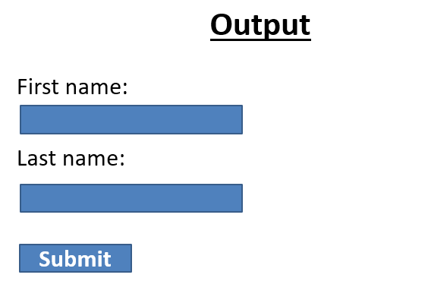
<!DOCTYPE html>
<html>
<body>
<h2>Application Form for job of Web Engineer</h2>
<form>
<label for="fname">First name:</label><br>
<input type="text" id="fname" name="fname" value=""><br>
<label for="lname">Last name:</label><br>
<input type="text" id="lname" name="lname" value="">
<button
type="button" id=“sbmtBtn" onclick=“sbmtFunction()">Submit
</button>
<script>
function sbmtFunction()
{
var x = document.getElementById(“sbmtBtn");
// Store data in a database on server – will be discussed later
}
</script>
</form>
</body>
</html>

